

Leading Educators Around the Planet (LEAP)

2011 Reciprocal Study Tour Report

Joanne Geary –Senior Curriculum Support Officer - CLIC

As a regional consultant for over two years I have facilitated state initiated programs and developed workshops to increase teachers’ knowledge of teaching literacy and to improve student literacy outcomes in many Western Sydney Region schools. With a move to the Curriculum and Learning Innovation Centre (CLIC) in May 2011 I found myself to be evaluating, refining, writing and training Regional Leaders in the current most successful literacy program in NSW, Focus on Reading 3-6. My interest and focus broadened to consider such questions such, “How can we make a good program an even better program? What makes a successful professional learning program? How can the ‘system’ support program implementation effectively? The opportunity to visit Canada, one of the higher performing OECD countries for literacy and numeracy, to see how professional learning was valued and embedded into teaching practice, was fantastic. By gaining knowledge of professional learning programs being implemented in schools in Ontario, I could make comparisons, reflect on the differences between the programs and ensure that Focus on Reading 3-6 continues to be refined and embedded with evidence-based research into quality literacy practice and an evidence base for quality professional learning for teachers and perhaps more importantly, for school leaders.

I was fortunate to be partnered with Bev Miller who works for the Ontario Principals’ Council. For the past seven years Bev has been deeply involved with the Leading Student Achievement (LSA) project as an executive member of the steering team, the recorder for the provincial symposia, developer of facilitators’ guides, moderator of numerous web conferences, regional facilitator for five regions, and coach to nine secondary schools involved in the project. The goal of the LSA project is to improve student achievement by developing and sustaining learning networks of principals, teachers and system level leaders. This program is a similar initiative to the Australian Government *National Partnership on Literacy and Numeracy* 2009-2011(NPLN) that targeted schools with poor performance in literacy or numeracy. The original Focus on Reading 3-6 program was one of three literacy program options for NSW schools under the NPLN.

The LSA project’s mandate is to:

* Improve student achievement in literacy and numeracy at the elementary and secondary levels
* Build and sustain the instructional leadership capacity of school leaders to support effective classroom practices in literacy and numeracy
* Engage in tri-level capacity building in schools, districts and the province
* Support principals in principal learning teams as they build professional learning communities in their schools
* Provide professional learning based on the "research-led practice and practice into research" mode

The challenge for the LSA project is to have every student in Ontario develop reading, writing, math and comprehension skills at a higher level by the age of 12. From my perspective, there could not have been a better program to learn about during my visit. Under LSA progress would be measured by ensuring that 75% of students reach the provincial standard (Ontario Ministry of Education, 2005). The Leading Student Achievement Project is based on a tri-level approach, often referred to by Michael Fullan, a Canadian and world leader on educational change, (diagram below).

**LEADING STUDENT ACHIEVEMENT**

INSTRUCTIONAL LEADERSHIP

INSTRUCTIONAL LEADERSHIP

INSTRUCTIONAL LEADERSHIP

**SCHOOL**

Professional Learning Communities

**DISTRICT**

Principal Learning Teams

**PROVINCE**

LSA STEERING TEAM

(ADFO, CPCO, OPC, EDU, CSC)

In NSW 2012 this tri-level approach for the implementation of a revised Focus on Reading 3-6 (FoR) is in keeping with the state government’s initiative, ‘Local schools, local decisions’. This initiative is primarily centres on meeting the specific needs of the ten regions across the state of NSW. It is also about capacity building at Regional and school levels. The three levels involved are State (the program has now been updated by the CLIC, Regions (Regional Leaders have been trained by CLIC and will in turn train and support school-based facilitators) and schools (school based facilitators will train and support teachers and school leaders in their own contexts. The addition of a school leader strand to the program will ensure school principals and executive teams will develop capacity as instructional leaders of literacy. Instructional leadership is an area that Ontario has worked hard to improve over the last ten years. When observing the diagram above, it is evident that instructional leadership permeates all aspects of the LSA initiative. We know from recent research by Viviane Robinson, John Hattie and research undertaken by leading Canadian academics, Ben Levin and Dr Kenneth Leithwood (the researcher throughout the LSA project’s life), that a school’s leadership influences (direct and indirect) are second only to the influence of teachers in regard to student achievement. Robinson noted that the pattern of relative impacts suggests that the more leadership is focused on the core business of teaching and learning the greater its impact.

The LSA project facilitators, such as Bev, provide support to school leaders as they:

* Improve literacy and numeracy achievement of students K to 12
* Work in Principal Learning Teams, hubs and networks to improve instructional leadership
* Build effective professional learning communities within and across their schools, district and province
* Use evidence-based inquiry to inform assessment for learning practices
* Establish and provide ongoing support of the Teaching Learning Critical Pathway process and other effective instructional practices
* Contribute to educational research
* Assess the effectiveness of the LSA project in meeting its mandate
* Determine professional learning needs of participants
* Acquire and analyse data about instructional strategies in literacy and numeracy, in particular the effectiveness of the Teaching Learning Critical Pathway process on student achievement
* Improve instructional practices across the province by applying the findings
* Influence future directions of the project.

The LSA project highlights six key learning conditions that robust evidence tells us have the most powerful direct effects on student learning:

1. **Academic Press:**

* Teachers and administrators set high but achievable goals for students
* Teachers believe in the capacity of students to achieve the high standards they set
* Students and parents respect and pursue the established goals
* Teachers make challenging demands in their classrooms
* Teachers provide the best quality instruction for students to achieve the goals
* Students come to value these goals
* There is a shared belief that the academic work in the school is job one.

1. **School Disciplinary Climate:**

* Impacts academic achievement and time for learning
* Is the collective responsibility of the entire school community to create
* Along with academic press, is one of two most important variables contributing to student achievement, especially in literacy and numeracy.

1. **Teacher Collective Efficacy**

* The group has confidence that by working collaboratively they will master the challenges.
* When a group of teachers think that together they have what it takes to meet the goals the school has set for them, the chances of accomplishing those goals are much higher.

1. **Teacher Trust**

* Teacher trust in colleagues, students and parents is the conviction that:
* Other staff are there for them and are trying to contribute to the same goal
* Students are on board with what is going on
* Parents can be trusted to do their part at home and at school

1. **Time for Learning**

* Academically engaged time
* School activities related to important goals
* A precious opportunity for actual learning and understanding to develop
* The simplest way of improving the quality of learning
* Job one for leadership in the school.

1. **Focused Instruction**

* Teaching with energy and urgency
* Attention to how time is being used
* Close monitoring of the activities that go on in the classroom
* Quick feedback to students about how they are doing.

Project facilitators work with school leaders and teachers to develop ‘Teaching learning critical pathways’ designed to personalise learning for every student. These pathways have been drawn from Ken Leithwood’s *Theory of Action,* which has been embedded into the Ontario Leadership Framework *(*diagram below). These pathways include Rational, Emotional, Organisational and Family paths. The work outlined by Crevloa, Hill and Fullan in *Breakthrough* is featured the Teaching Learning Critical Pathways. We too, have heavily referenced this text in FoR 3-6. It was quite affirming to have found many similarities between NSW and Canadian initiatives, programs and systems.

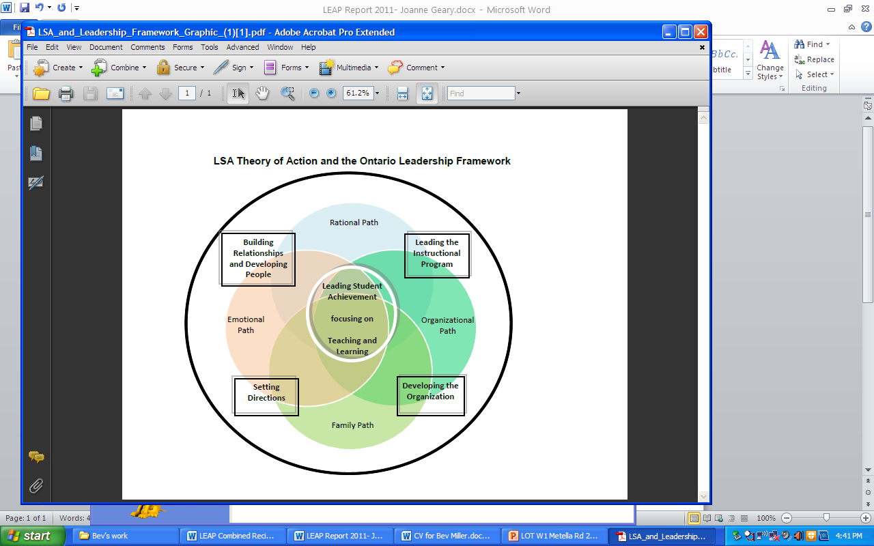

I was extremely lucky to have attended a LSA symposium during my visit. During this day I heard terms such as collaborative cycles, feedback, professional learning communities, co-creation, collaborative inquiry; all terms we have embedded into FoR 3-6. I was able to hear Ken Leithwood speak about the LSA project and to also hear J. Douglas Willms speak about Canadian PISA (Program for International Student Assessment) results and their implications for teachers and school leaders. He gave me some comfort that we are addressing the literacy issues for student transiting from the ‘learning to read’ to ‘reading to learn’ years of schooling in FoR 3-6. Interestingly, Willms noted that 80% of Canadian students have a flat trajectory for Literacy progress from year three onwards. This gives cause for concern as Australia falls behind Canada on this international test. Of perhaps more concern Willms noted 40% of 15 year old students (in general) are suffering from depression. This creates a major concern for the functioning of healthy societies across the world in the not too distant future. More information about the LSA program can be accessed through the following link: <http://resources.curriculum.org/LSA/about.shtml>. There are some fabulous videos and papers available for use from this site.

Elaine Hine, a Student Achievement Officer from the Literacy and Numeracy Secretariat, kindly included me in a Principal Learning Team meeting in the Thames Valley Ontario. Here I was able to see Principal Learning Teams in action, planning the literacy program for their schools with the support of district literacy coaches. I was able to make a connection with our NSW Quality Teaching model as questions asked (such as, “What do I want my students to learn? Why does that learning matter? What am I going to get the students to do or produce? How well do I expect them to do it?”) were similar to those we use when planning during professional learning sessions. The difference between this session and many of our NSW professional learning sessions, was that the Canadian group was solely made up of school leaders whereas our NSW school leaders were largely absent from professional learning and planning sessions during the initial roll-out of the FoR 3-6 program. At the time the original program was written the role of instructional leadership was not realised as paramount to the program’s success. With the latest research on hand and the addition of a school leader strand in the revised program model, we hope to encourage greater Principal participation in professional learning with staff. Robinson’s research found that leadership which promotes and directly participates with teachers in formal and informal professional learning has the greatest effect on student achievement. She found this to have an effect size of 0.84. The FoR 3-6 2012 program roll-out will see over 1800 teachers, over 400 school leaders, approximately 300 school based facilitators and our 30 regional leaders from across NSW participating.

The LEAP experience is enriching and rewarding on both personal and professional levels. It is an opportunity to compare, contrast, reflect, research and adapt ideas, methods and even systems. I would thoroughly recommend this reciprocal study tour as an opportunity to meet with like-minded educators’ intent on making a difference to the lives of students.