Indigenous education: Translating policy into practice
LEAP Action Research Project 2011
Leonie Seaton Principal Narraweena Public School
Background:
- Narraweena Public School is located on the northern beaches of Sydney. 353 students, 8 identified aboriginal students.
- Commenced as principal T2 ‘09. Aboriginal education at Narraweena ’09:
  - DET acknowledgement of country used at assemblies
  - teaching programs included a page headed “Aboriginal Perspectives” with staff including items such as NAIDOC week activities
  - personalised learning plans (PLPs) written for aboriginal students however, these were in need of improvement
  - no Aboriginal Education committee, rather an Aboriginal Education contact person who coordinated NAIDOC week activities.
- Term 3 2009 Leadership Forum focusing on the implementation of the 2008 Aboriginal Education and Training Policy. Attended by Sarah Ambrose, who indicated an interest in leading the school’s Aboriginal Education committee.
- Term 4 2009 committee established with representation from staff, parents, community members, and local Aboriginal Educational Consultative Group (AECG). Focus for first meeting was to look at the policy and to begin to work through the document ‘Aboriginal Education and Training Policy. Turning policy into action: A guide for local planning groups.’ This document assists communities to explore the following four focus areas of the policy by investigating what is already done and what needs to be done in a particular school or TAFE setting:
  - Leadership, planning and accountability
  - Ongoing learning for staff and students
  - Relationships and pathways
  - Teaching and training
- Committee determined the need to focus on two areas in particular
- Improving learning outcomes for Aboriginal students
- Providing opportunities for all students, staff and wider community to acquire knowledge and develop deeper understandings of Aboriginal histories, cultures and experiences.

- Throughout 2010 and 2011 the following achievements have been made against both of these focus areas:
- All staff undertook an aboriginal awareness course at Brookvale TAFE SDD 3 2010
  - ES1, S2, S3 teachers worked with Aboriginal Education consultant to rewrite particular units of work to embed aboriginal perspectives (Me; Local catchment area; Murray-Darling Basin environmental case study)
  - SRC worked with local AECG representative and grandmother of one of our students to write Narraweena PS’s acknowledgement of country with input from all students
  - Purchase of resources to support units; committee members donated maps of aboriginal Australia for use in classrooms; Guringai posters developed by Julie Janson detailing history of aborigines on the northern beaches available for use.
- Release time allocated for teachers to develop PLPs for Aboriginal students with parental input. Reviewed each term.
  - Norta Norta NAPLAN funding used to tutor individual students performing below minimum standards in literacy and numeracy. Focus on whole school areas for improvement – comprehension, vocabulary knowledge and problem solving
  - Homework club to support students with tasks and to provide access to computers.

Progress had been made on the implementation of the Aboriginal Education and Training policy (2008) at Narraweena Public School however; we had only made small steps along a pathway that stretches far ahead. The opportunity to participate in the LEAP program meant that I would be able to explore the ways in which indigenous students are supported in two particular schools in Ontario, Canada. The next section of this report explains some of the indigenous education initiatives in Ontario, as well as ways in which the two schools I visited were translating aboriginal educational policy into practice.

LEAP Partner: Pat Douglas Principal Plum Tree Park Elementary School – Mississauga Ontario 735 students; dual track school (English and French Immersion)
Additional visit: Roseneath Elementary School; Principal Lyn – located alongside Alderville First Nation Reservation – Mississauga tribe – Ojibwe (ojibway) nation

Aspects of policy for project investigation:
- Improving Aboriginal students’ learning outcomes.
- Broadening student and teacher knowledge of aboriginal cultures and histories.
Ontario – Relevant policies:
Ontario. Ministry of Education (2007) Ontario First Nation, Metis, and Inuit Education Policy Framework, Toronto: Author.
Ontario. Ministry of Education (2009) Realizing the promise of diversity: Ontario’s equity and inclusive education strategy Toronto: Author
The above strategy has three goals to meet the expectations of Ontario’s diverse society for a quality public education system for all:
- High level of student achievement
- Reduce gaps in student achievement
- High level of public confidence
Examples of actions supporting improvement in indigenous education at a provincial level include:
- Ontario Focused Intervention Partnership (OFIP) $25 million to support schools with continuous improvement. Includes many schools with significant aboriginal student populations. Literacy and numeracy – resources to support First nation students based on quantitative data; importance of oral language + resources that reflect aboriginal cultures
- Tutors in classrooms project - $2.5 million 2006-7
- Parents reaching out grants to support parent/school relationships + outreach for community support
- Student identification processes in place for voluntary, confidential aboriginal self-identification
- Teacher professional learning Webcasts – eg “Unlocking the potential of aboriginal students”, “Differentiating Instruction”; providing anywhere, anytime access to relevant professional learning
- Grade 1-12 curriculum includes 7 native languages that may be studied as an alternative to French.
- Curriculum review to ensure First Nation content integrated as appropriate. Years 1-6 subjects including Social Studies, Mathematics, Language
- Implementation of equity walks in schools to “sharpen and focus the instructional leadership lens and allow the gathering of observational data to confirm or challenge assumptions regarding school improvement and equity in the building.” (OPC Equity and Inclusive Education Team)
- Research monograph by Toulouse (2008) distributed by the Ontario Literacy and Numeracy Secretariat asks the following key questions:
- What strategies currently work for aboriginal students and why are they so important for creating meaningful change?
- What are the day-to-day implications for educators endeavouring to ensure aboriginal student needs are met?
Toulouse discusses the changes that are needed to improve outcomes for aboriginal students in light of a cultural framework based on the “living teachings” of the Ojibwe people.
Table 1 Ojibwe Good Life Teachings and Implications for Education (Toulouse, 2008, p.2)
Teaching | Implications for education
Respect | Having high expectations for aboriginal students and honouring their culture, language and world view in our schools
Love | Demonstrating our belief (as educators) that all aboriginal students can and will succeed through our commitment to their learning-teaching styles
Bravery | Committing to change our school curriculum through including the contributions, innovations and inventions of aboriginal people
Wisdom | Sharing effective practices in aboriginal education through ongoing professional development and research that focuses on imbuing equity
Humility | Acknowledging that we need to learn more about the diversity of aboriginal people and accessing First Nation resources to enhance that state
Honesty | Accepting that we have much to learn from one another and reviewing the factors involved to encourage change in the education system
Truth | Developing measurable outcomes for aboriginal student success and using them as key indicators of how inclusive our curriculum and pedagogy really are.

Translating policy into action
Plum Tree Park Elementary School
- No identified First Nation students – issue of non-identified First Nation students
- Units of work developed by Ontario Ministry of Education – Y6 First Nation people and early explorers; Year 5 Early civilizations; Year 4 Canada’s provinces, territories and regions; Year 3 Early settlements in Upper Canada; Year 2 Traditions and celebrations.
  - Year 6 students were very interested in discussing indigenous issues in Australia. They enjoyed a book I provided on aboriginal dreaming stories and related it to similar work they were doing on First Nation and Inuit cultures.
Translating policy into action at Plum Tree Park Elementary School is part of the focus on equity and inclusion for all students

Roseneath Elementary School
- Seven “good life” elements are used explicitly to underpin learning across all subjects. The elements are evident in many aspects of the school culture including:
    - Student work displays in corridors and classrooms
    - Welcome to the school
    - Teaching programs including Ojibwe language
- Literacy programs – informed by continuous data analysis
  - Teacher professional learning - Freebody and Luke’s four roles/resources of the reader and writer; explicit, direct teaching focusing on metacognition that teaches students what they need to think about when they are reading.
  - Teacher programs - Literary texts: connection with texts; visualisation, inferring, transformation – how does the text change you as a reader? Factual texts zooming in to locate different aspects of text; asking questions and inferring, determining importance of information, connection, synthesising/transformation.
    - Modelled, guided and independent practice + application to real life reading and writing experiences

- Resources –
  - Ojibwe language teacher – works across school with all students learning Ojibwe language
  - Teaching assistant supporting identified students
  - Library - resources to support curriculum areas evident
- Working closely with First Nation band (chief and council) - homework support in community centre, meetings with parents to discuss how reading and math are taught, review of test results, gradually building trust of community in school system.
Translating policy into practice at Roseneath Elementary School focuses on
- Respect for Ojibwe culture
- Building trust with First Nation families
- Professional learning to support teachers to understand and meet the educational and social needs of First Nation students
- Resources to support teaching programs

Images – Roseneath Elementary School
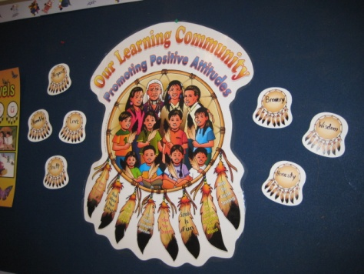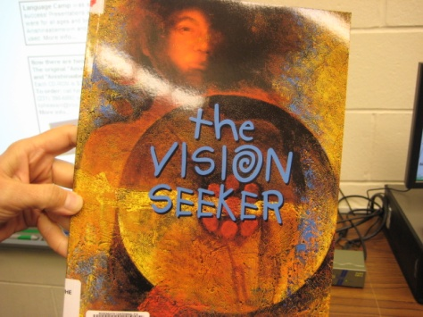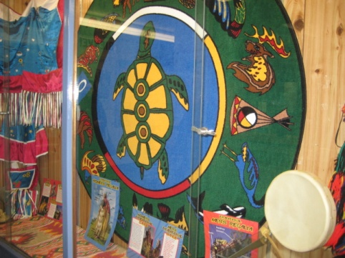
Good life teachings focus areas Story focusing on good life teachings Display at entrance to school

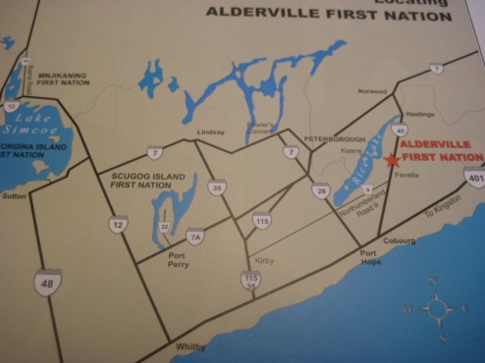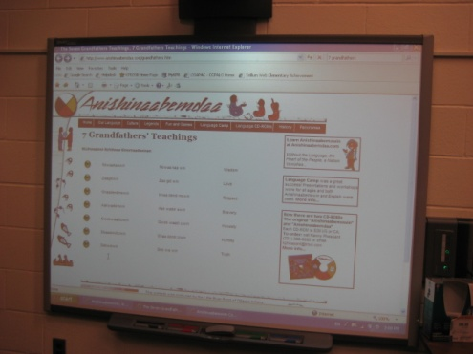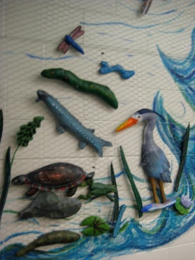
Alderville First Nation Reservation IWB lesson “The Vision Seeker” Section of interactive storytelling display in corridor

Implications for translating policy into practice at Narraweena Public School
Whilst we have made a level of progress in implementing the DET’s Aboriginal Education and Training Policy (2008) at Narraweena PS, the work is ongoing. The implementation of an equity walk as described in the OPC equity walk template will support us to gain new insights into silences, gaps and future directions for our work in the area of aboriginal education. A new lens through which we view our work will assist us to continue to explore our ongoing challenges in the following areas that have been the focus on my LEAP project.

- Improving learning outcomes of Aboriginal students
  - Continual monitoring of available data to support learning needs of aboriginal students through:
    - Learning Support Team focus
    - Teacher Professional Learning - What data do we need to collect and analyse to support our planning? Review this focus regularly
  - Explicit teaching to support areas for growth in literacy and numeracy through:
    - Teacher professional learning
- What is it our students need to know to be successful readers, viewers and constructors of texts?
- What do our students need to know to support their growth in working mathematically?
    - Focus on talking and listening to support developing student understandings in literacy and numeracy
    - Ongoing grade/stage discussions with STLA and teaching peers
    - Clearly stated learning goals for each child shared with students and families
    - Provision of descriptive feedback to students to support self-assessment of learning goals
    - Improved handover of students from year to year with a clear focus on areas of strength and areas for improvement
    - Continuing to celebrate student success – NSR AECG awards
    - Continuing funding for homework club.
  - Respectful communication with parents through:
    - Continuing discussions when preparing PLPs – if parents unable to attend send copy of plan home
    - Continuing discussion around student wellbeing issues – improved focus on this as a two-way process.

- Providing opportunities for all students, staff and wider community to acquire knowledge and develop deeper understandings of Aboriginal histories, cultures and experiences.
  - Continue to work with teachers to embed aboriginal perspectives into units of work through:
    - new Australian curricula
    - ongoing teacher professional learning
    - continuing to review current and new resources with AECG to ensure that they are culturally and historically appropriate.
  - Continue work with local AECG and aboriginal community around guidelines for respecting, valuing and promoting local aboriginal cultures and protocols through:
    - school’s aboriginal education committee
    - support from Warringah Council Aboriginal Heritage officer

References
NSW Department of Education and Training (2008) Aboriginal Education and Training Policy, Sydney: Author
NSW Department of Education and Training (2009) Aboriginal Education and Training Strategy 2009-2012, Sydney: Aboriginal Education and Training Directorate
NSW Department of Education and Training (2009) ‘Aboriginal education and training policy. Turning policy into action: A guide for local planning groups’, Sydney: Aboriginal Education and Training Directorate
Ontario. Ministry of Education (2007) Ontario First Nation, Metis, and Inuit Education Policy Framework, Toronto: Author.
Ontario. Ministry of Education (2009) Realizing the promise of diversity: Ontario’s equity and inclusive education strategy Toronto: Author
Toulouse, P.R. (2008) ‘Integrating aboriginal teaching and values into the classroom’, Research Monograph #11, Literacy and Numeracy Secretariat, Ontario.
Ontario Principals’ Council Equity and Inclusion Team ‘Equity walks’, adapted from template developed by Dr Bev Freeman, handout at LEAP Conference Toronto October 5 2011.

